CONFIGURATION:

npm config set prefix ‘~/.npm-global’

export PATH=~/.npm-globlal/bin:$PATH

source ~/.

echo ‘export PATH=~/.npm-globlal/bin:$PATH>>~/.’

npm install -g aws-azure-login

aws-azure-login --configure

aws-azure-login --mode gui

aws s3 ls –no-verify-ssl

RANGE:

10.1.128.0/21

10.1.128.0 - 10.1.135.255

10.1.128.1 - 10.1.135.254

B C SACHIN

BCSACHIN@DELOITTE.COM

QUESTION 1:

STEP 1: Create subnet by providing resource “aws_subnet” “name”{

//details and tags

}

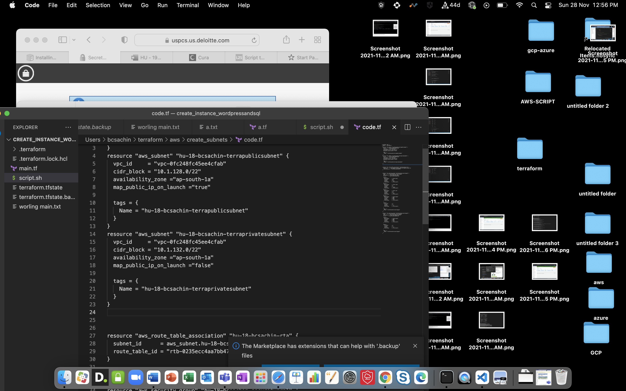

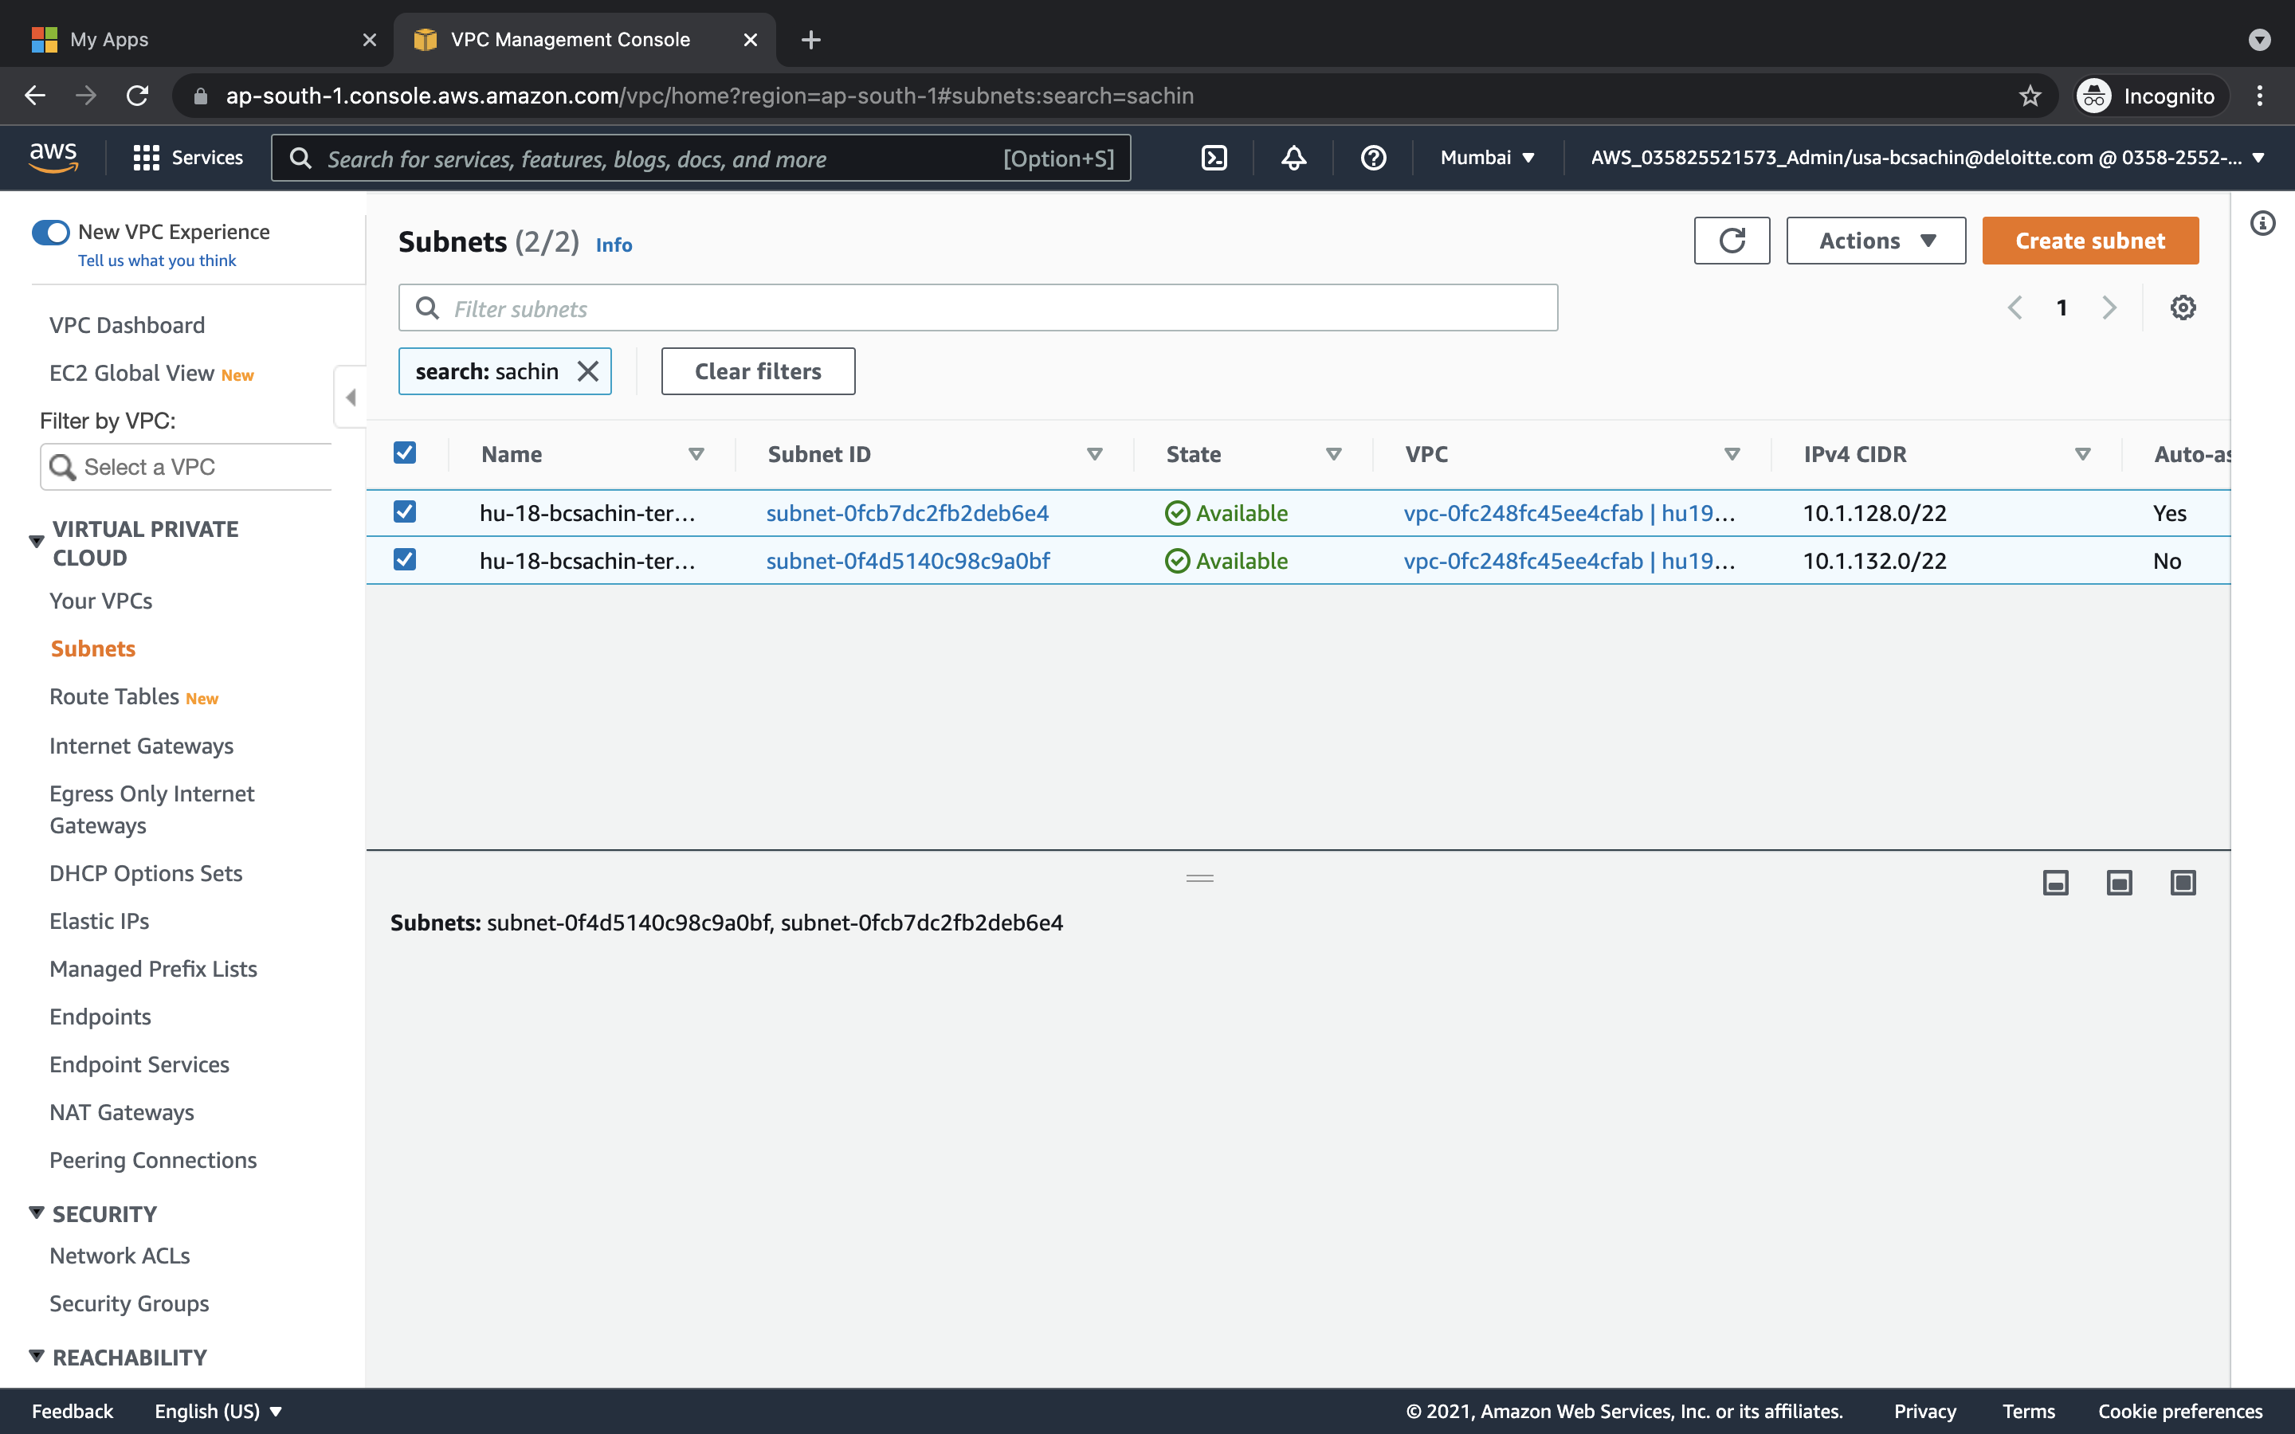

Step 2:create security group 1 for public subnet which accepts all inbound and outbound traffic

STEP3: create security group 2 for PRIVATE subnet which accepts all inbound and outbound traffic from my subnet subnet range

ingress {

description = "allow all"

from_port = 0

to_port = 0

protocol = "tcp"

cidr_blocks = ["10.1.128.0/21"]

}

egress {

from_port = 0

to_port = 0

protocol = "-1"

cidr_blocks = ["10.1.128.0/21"]

}

Step4: now create instance and install wordpress using userdata script

Network interface created to connect to our insatance

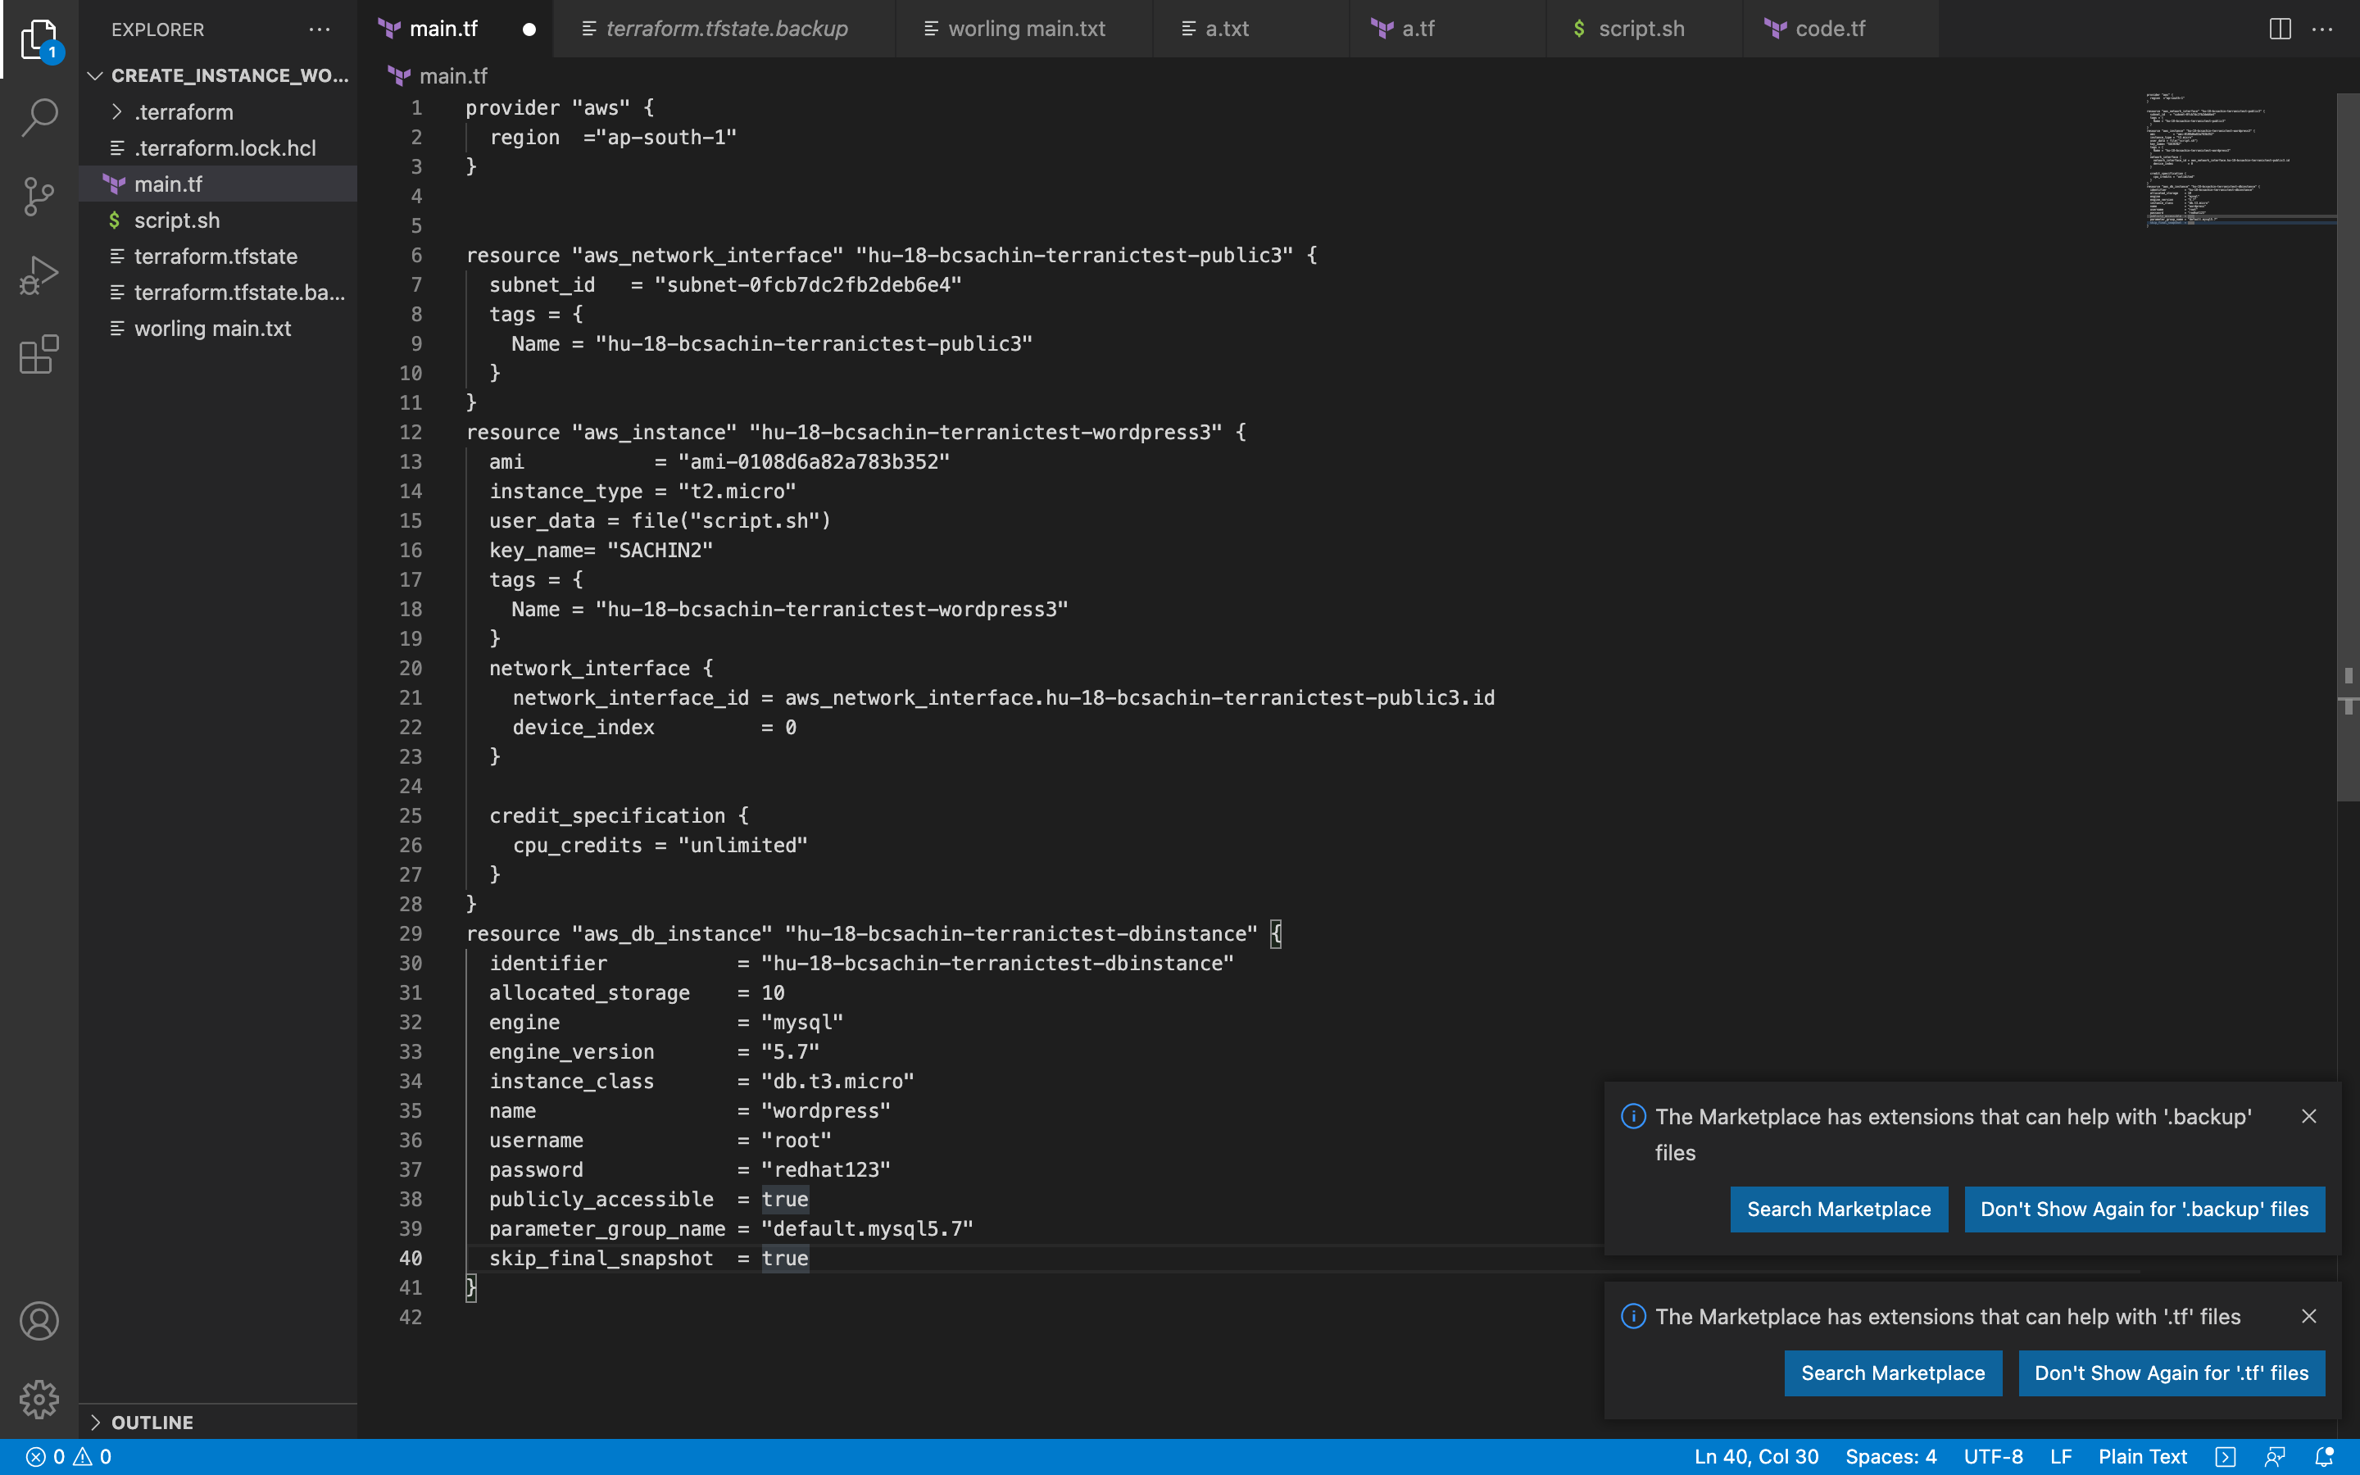

Script,sh looks like

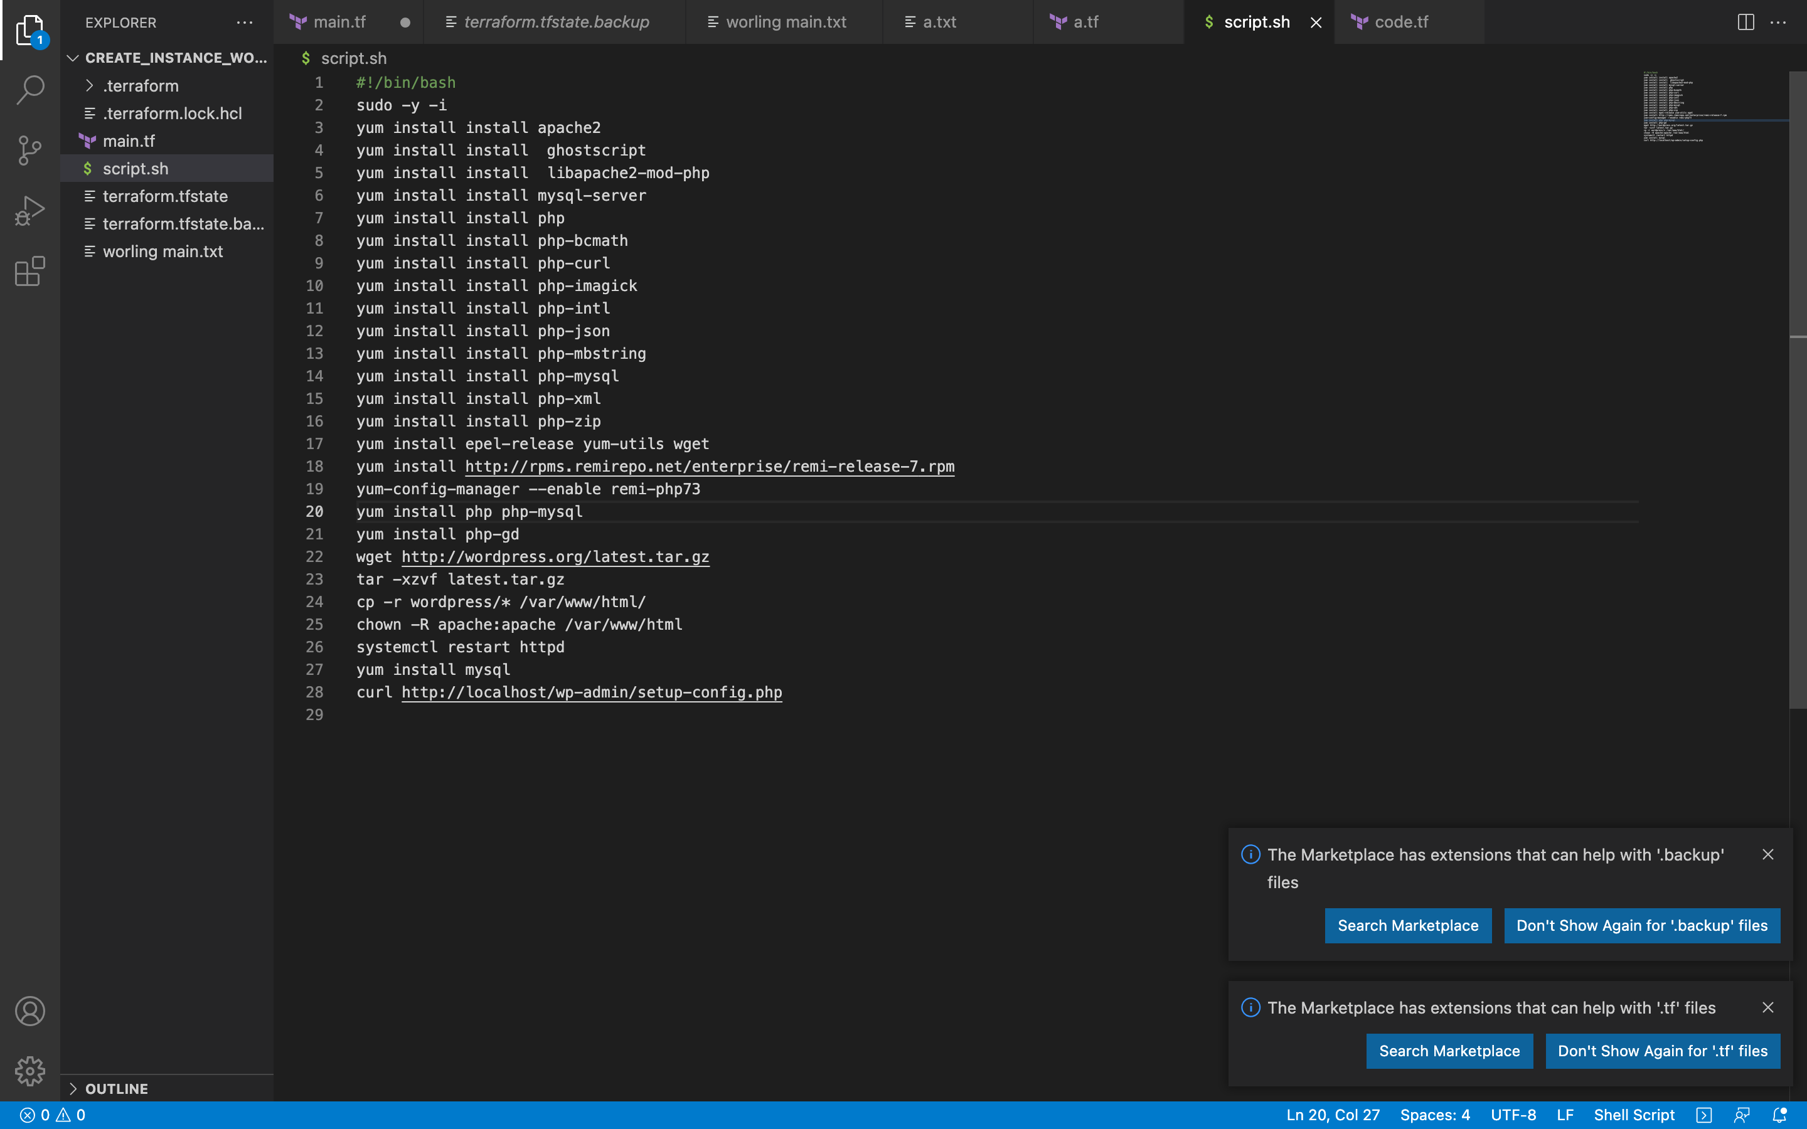

To verify above script working move to default html == /var/www/html and ls

Weget all word press file installed

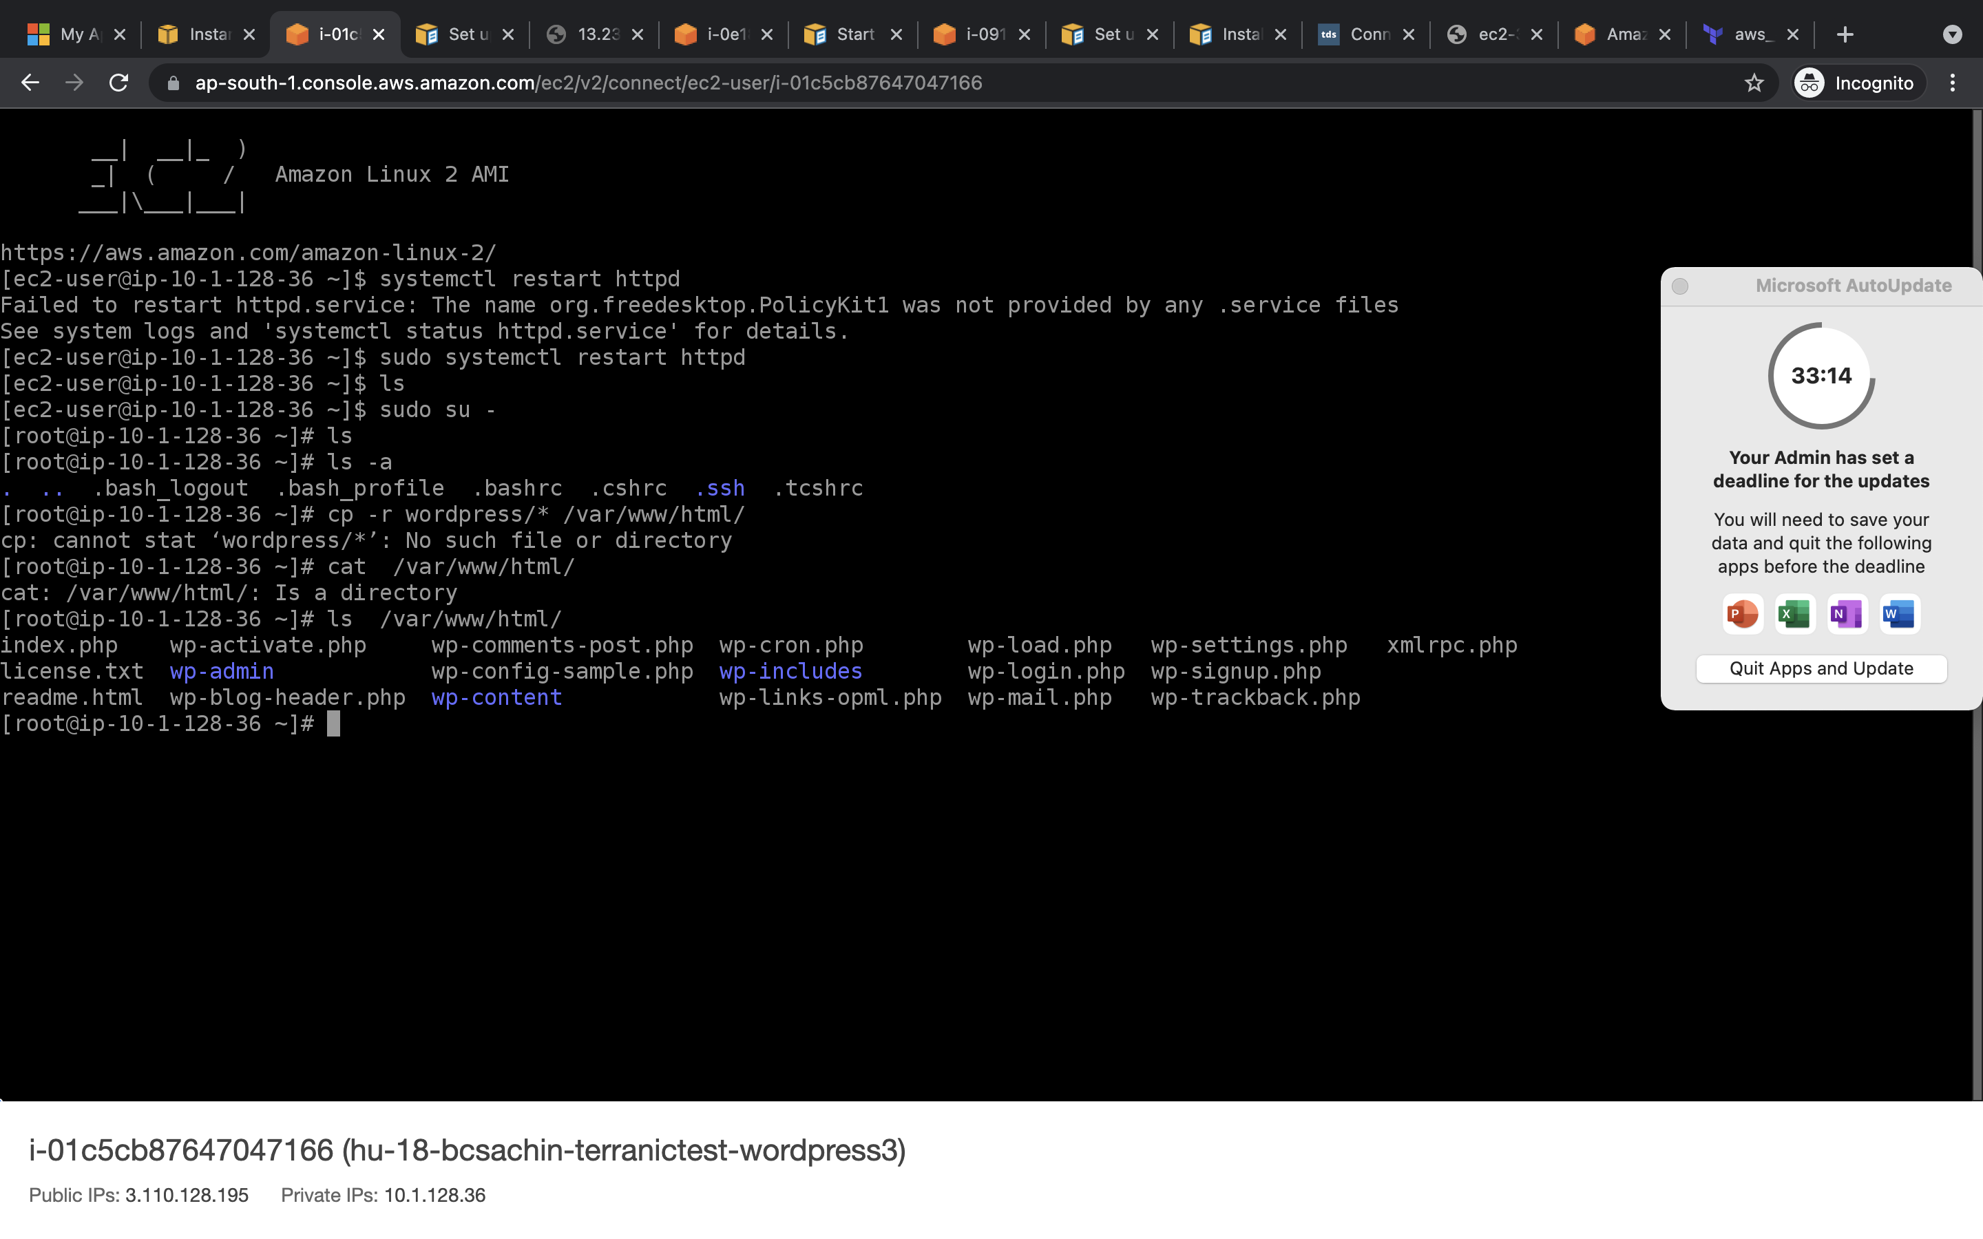

Now create rds

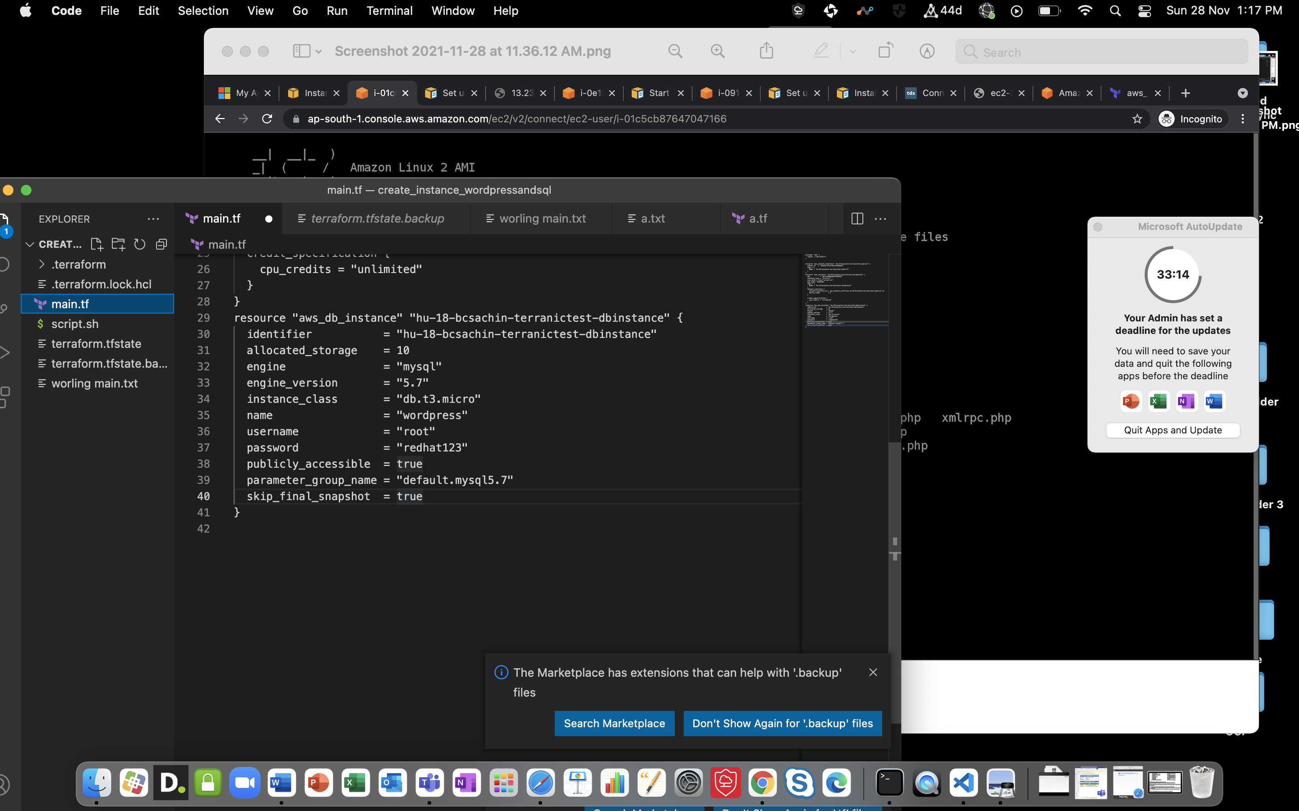

We got error

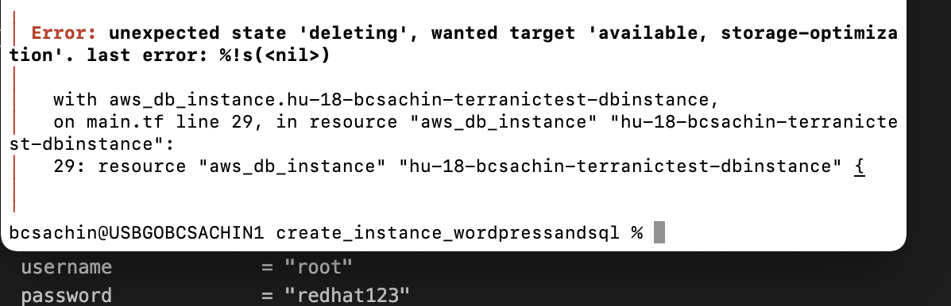

* //CODE//

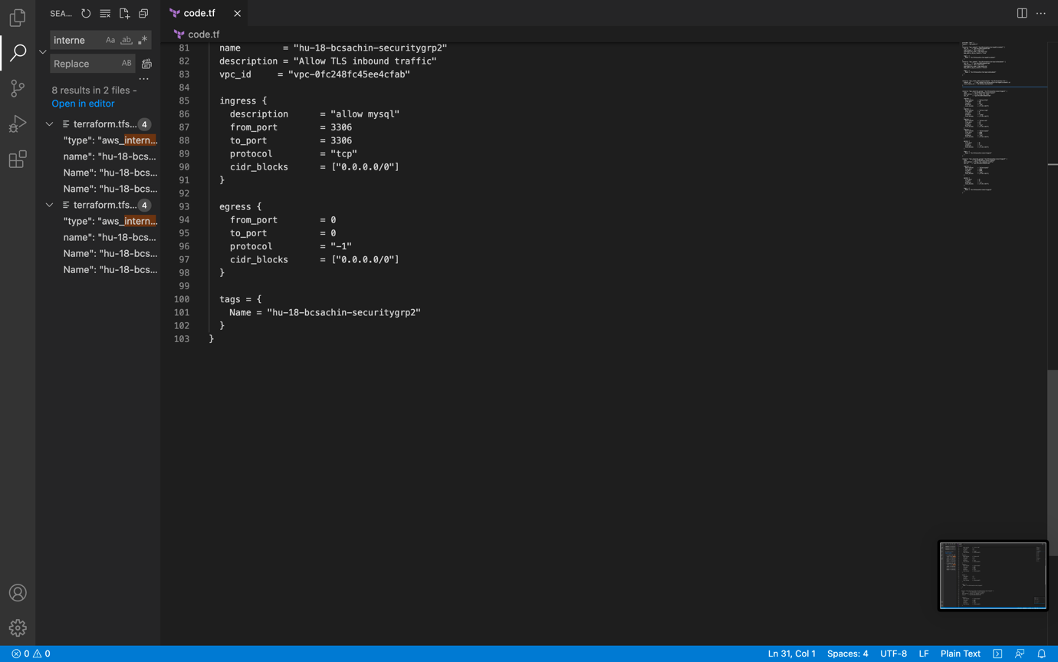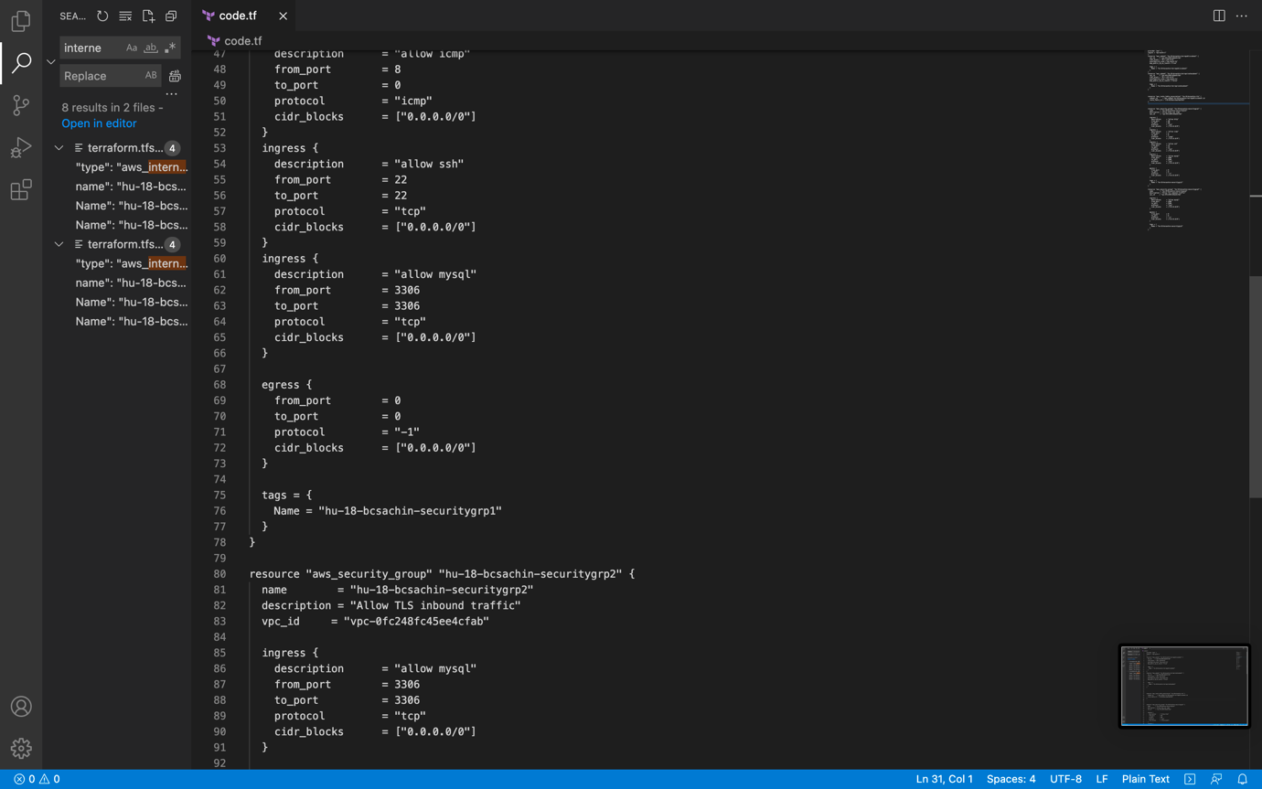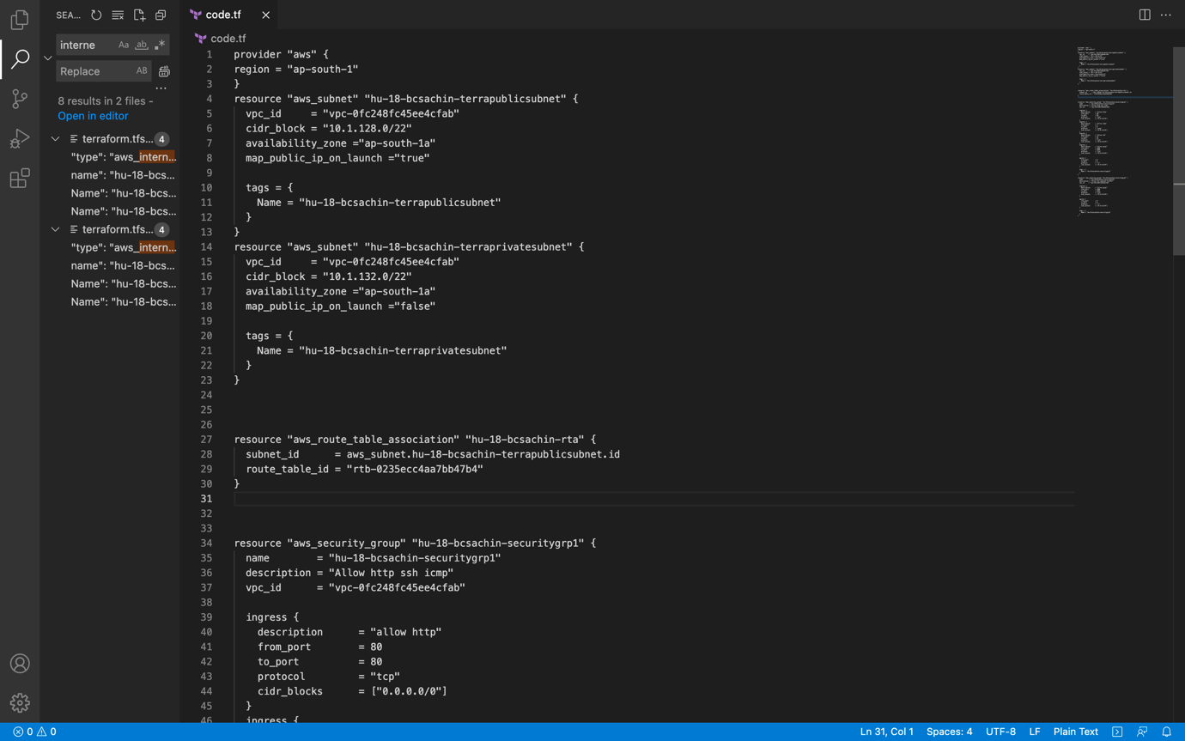

//code end

Approach:

Once rds created add the details in wordpress config

And run data will get store in rds

TERRAGOAT INSTALLED

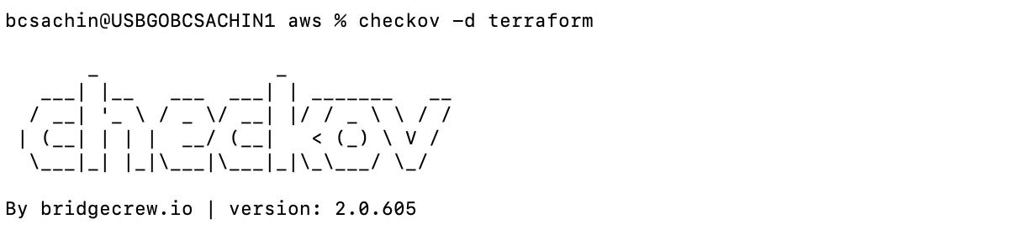

/////azure

hu19-tf-vnet

Created By

linker-<FIRST_NAME>

Env

HU-19

Managed By

Terraform

//code

QUESTION 2 :

AZURE

* Created subnet -> resource "azurerm_subnet" "hu19bcsachinsubnet"
* Create public Ips resource "azurerm_public_ip" "hu19-bcsachin-ip"
* Create Network Security Group and rule
* resource "azurerm_network_security_group" "hu19-bcsachin-nsg"
* Create network interfaceresource "azurerm_network_interface" "hu19-bcsachin-nic"
* Connect the security group to the network interface resource "azurerm_network_interface_security_group_association" "hu19-bcsachin-nsgassoc"
* Create storage account for boot diagnostics
* resource "azurerm_storage_account" "hu19bcsachinstorageacc"
* create ssh key resource "tls_private_key" "example_ssh"
* create container resource "azurerm_storage_container" "hu19-bcsachin-storagecontainer"
* Create virtual machine
* resource "azurerm_linux_virtual_machine" "hu19-bcsachin-vm"
* write a script to install docker and download giver git repo

script to launch above mentioned respectively

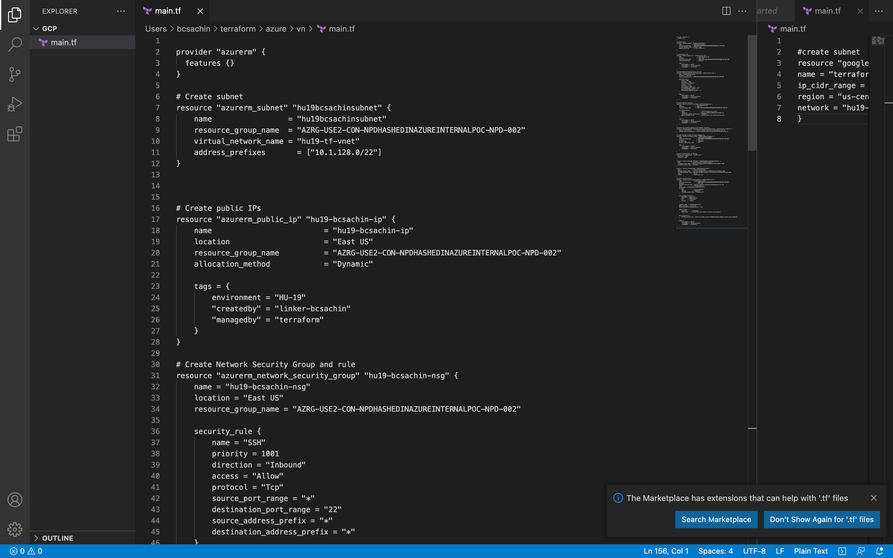

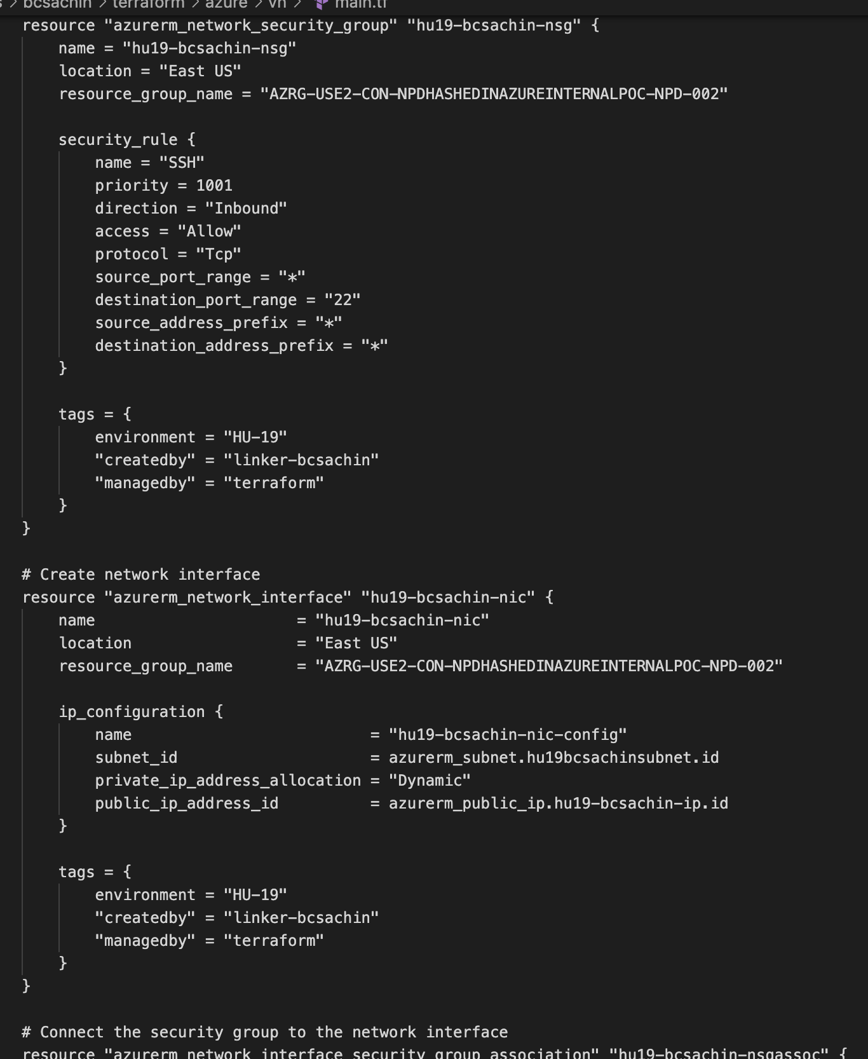

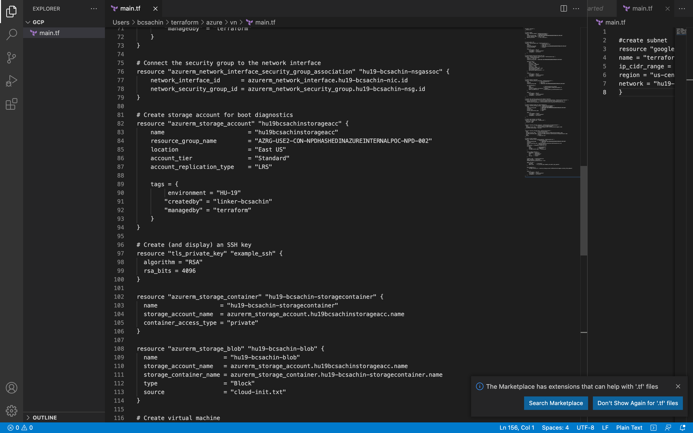

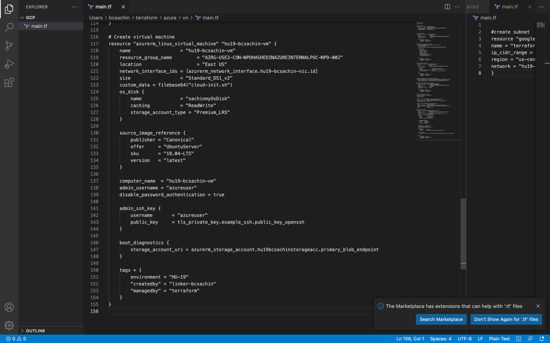

*

Script file

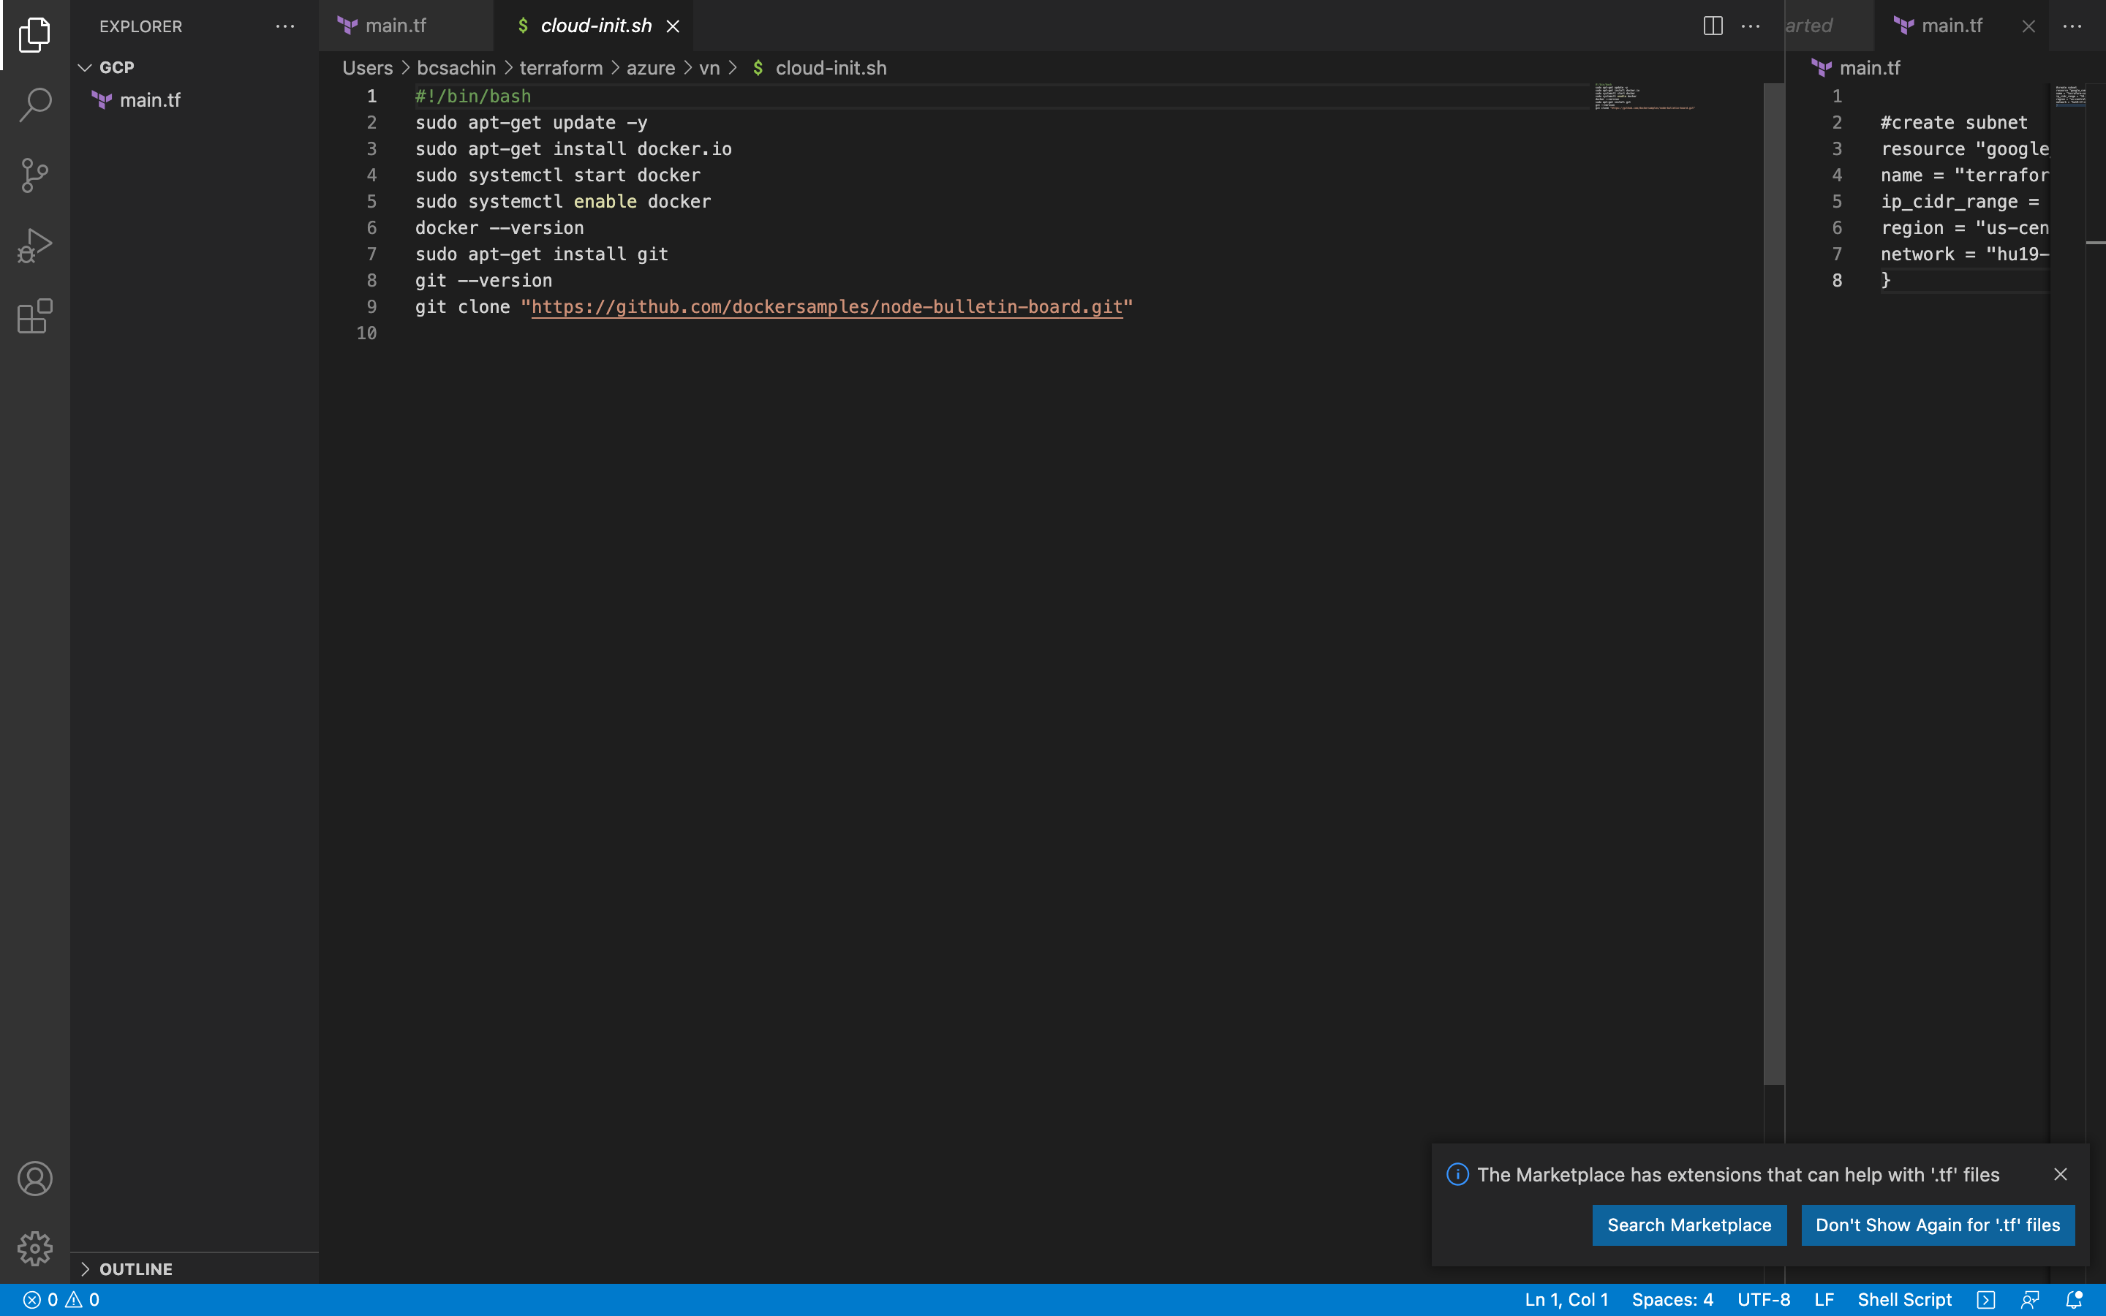

* storage account
* 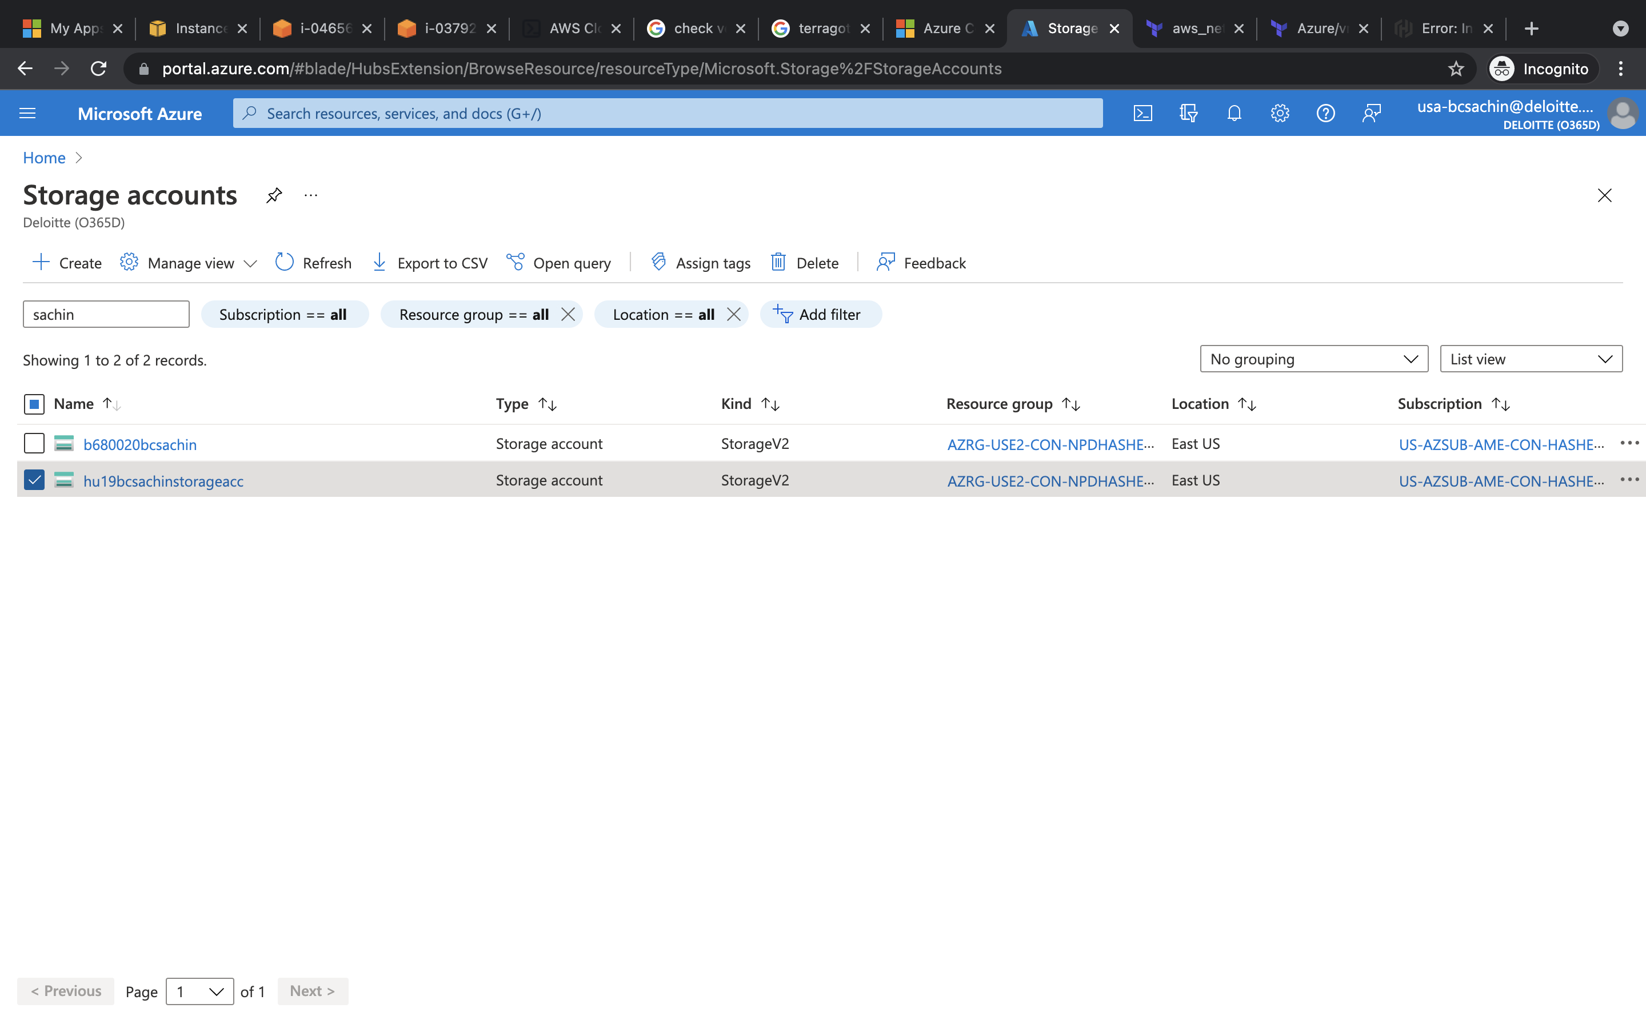

Storage account with boot diagnostics

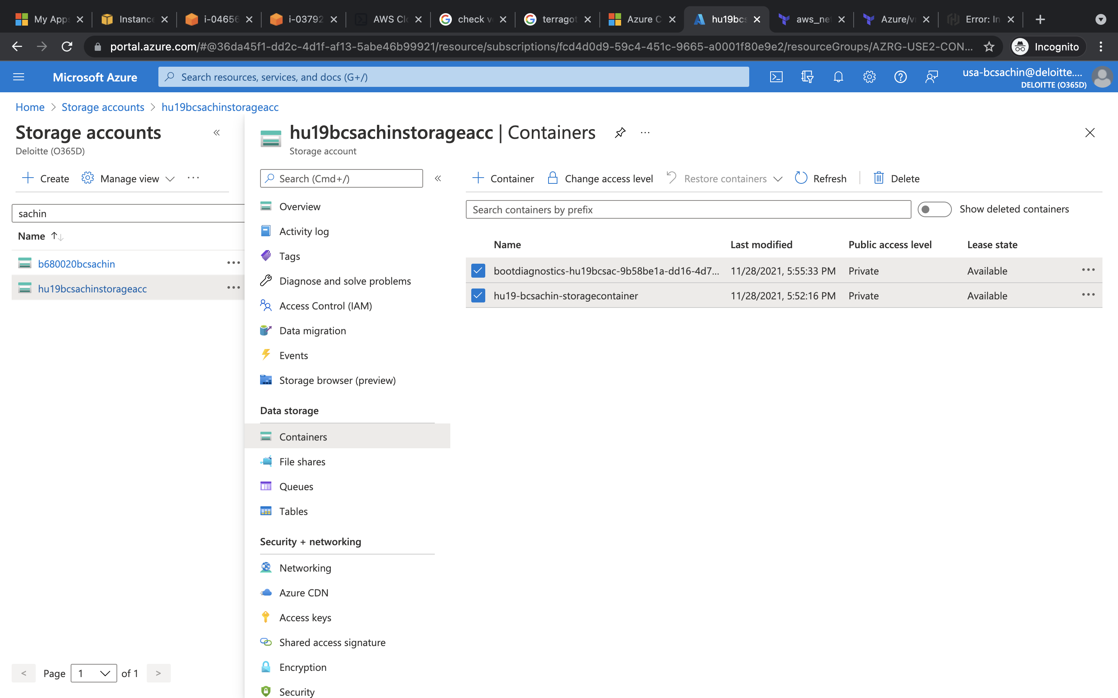

Blob added

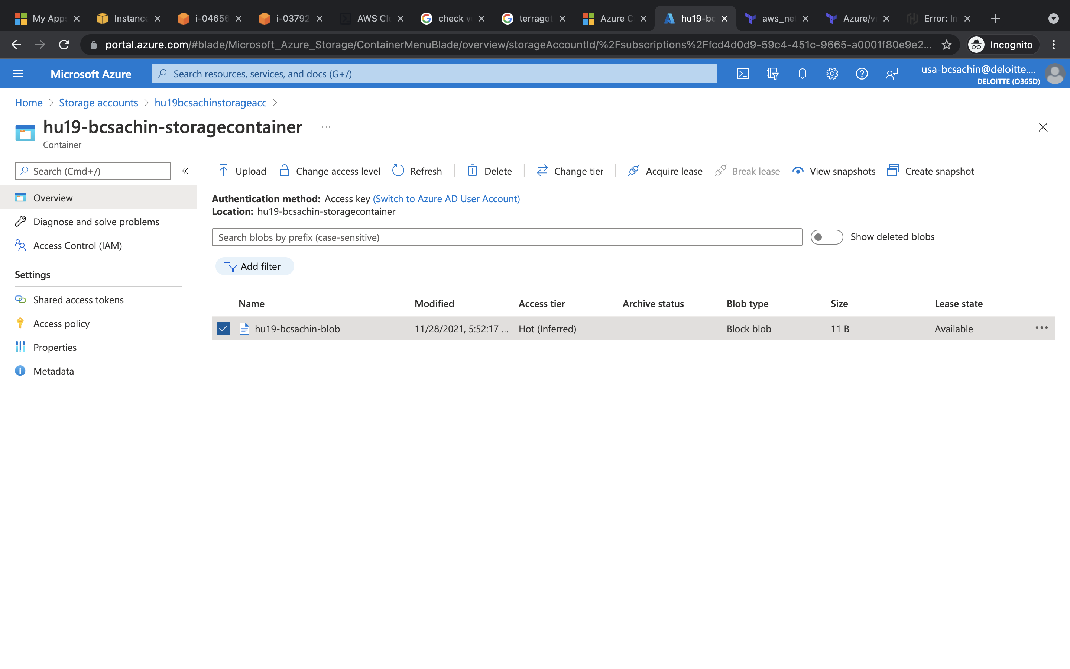

////

Gcp

CREATE SUBNET

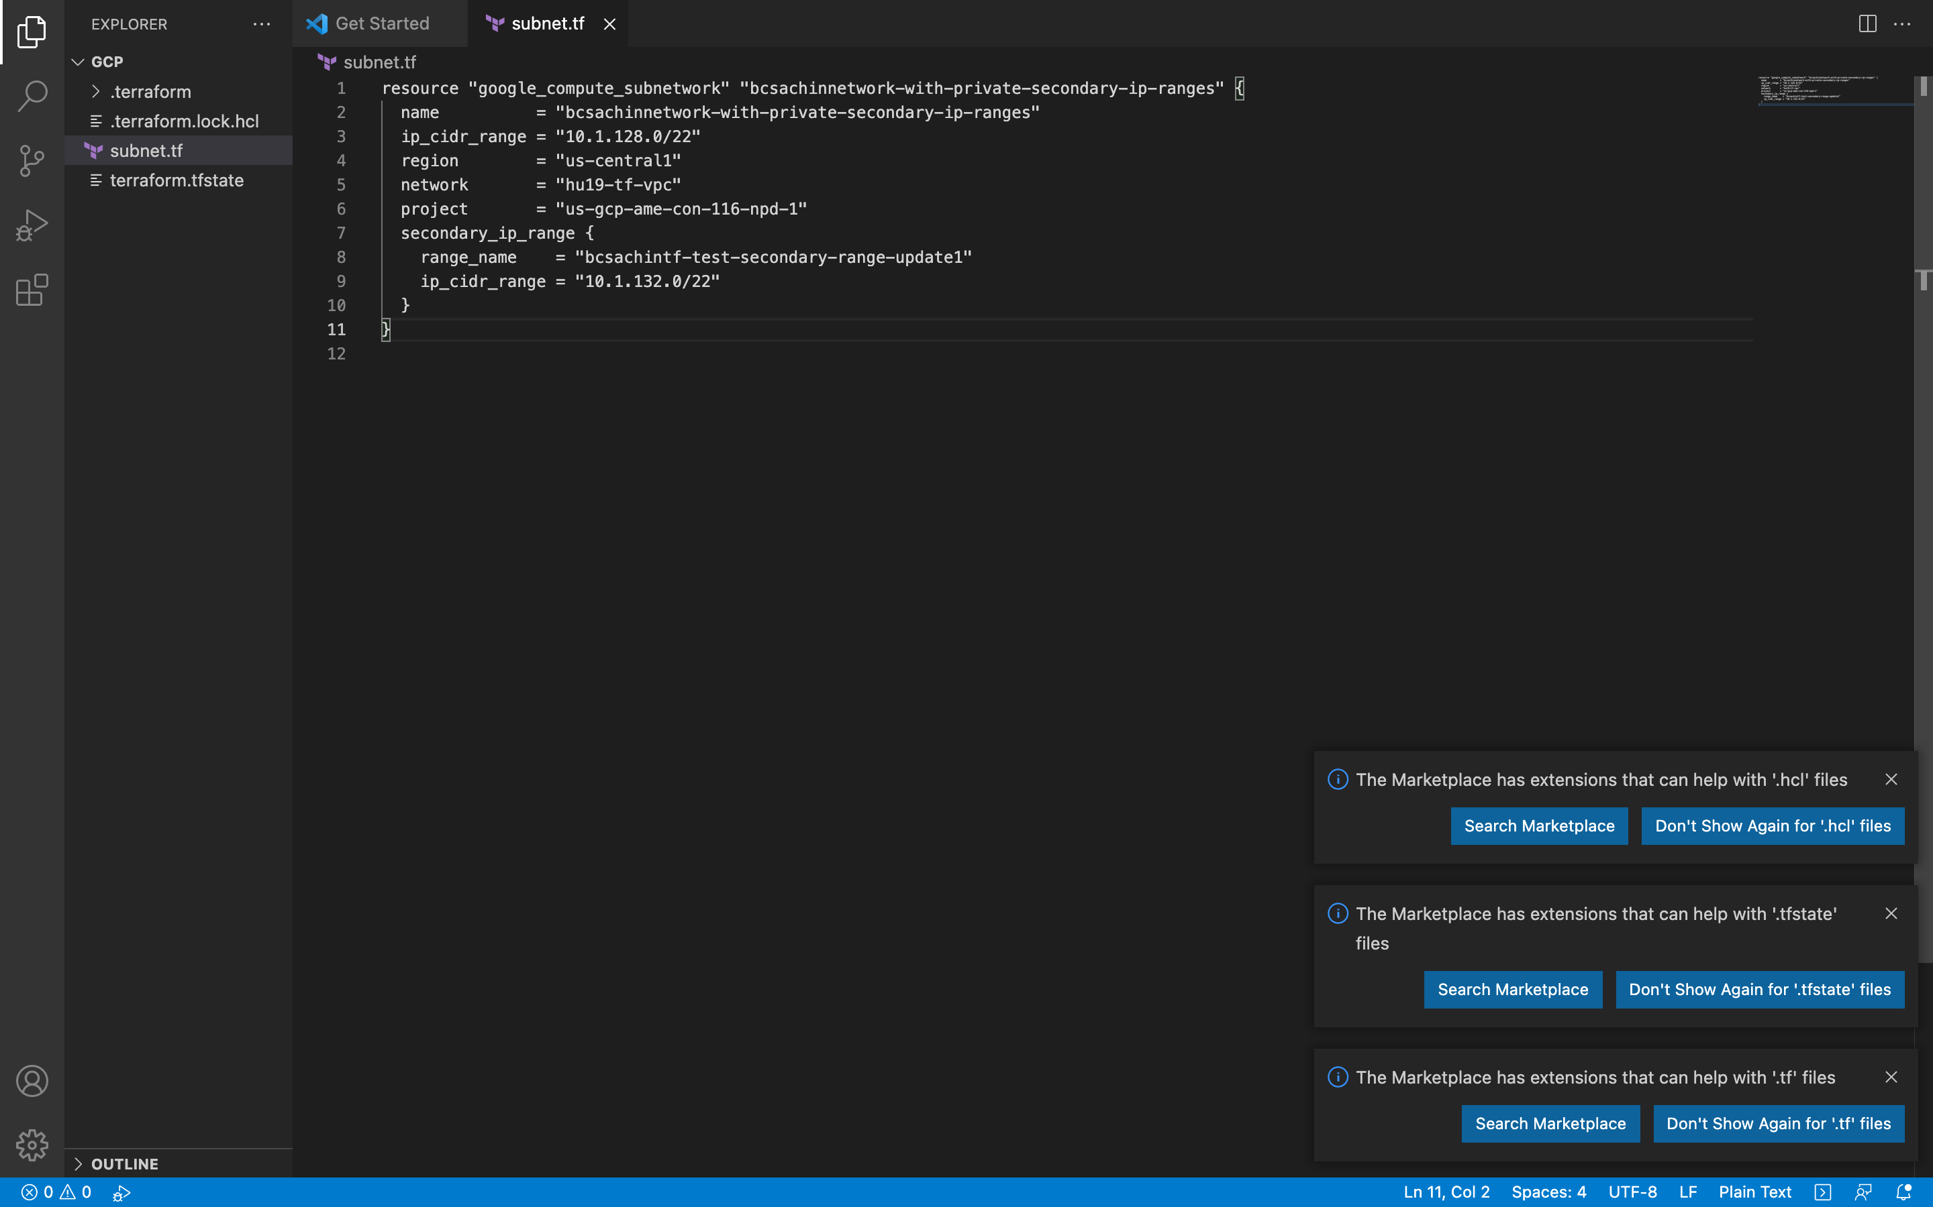

NOW RUN terraform init, terraform plan , terraform apply to create resource

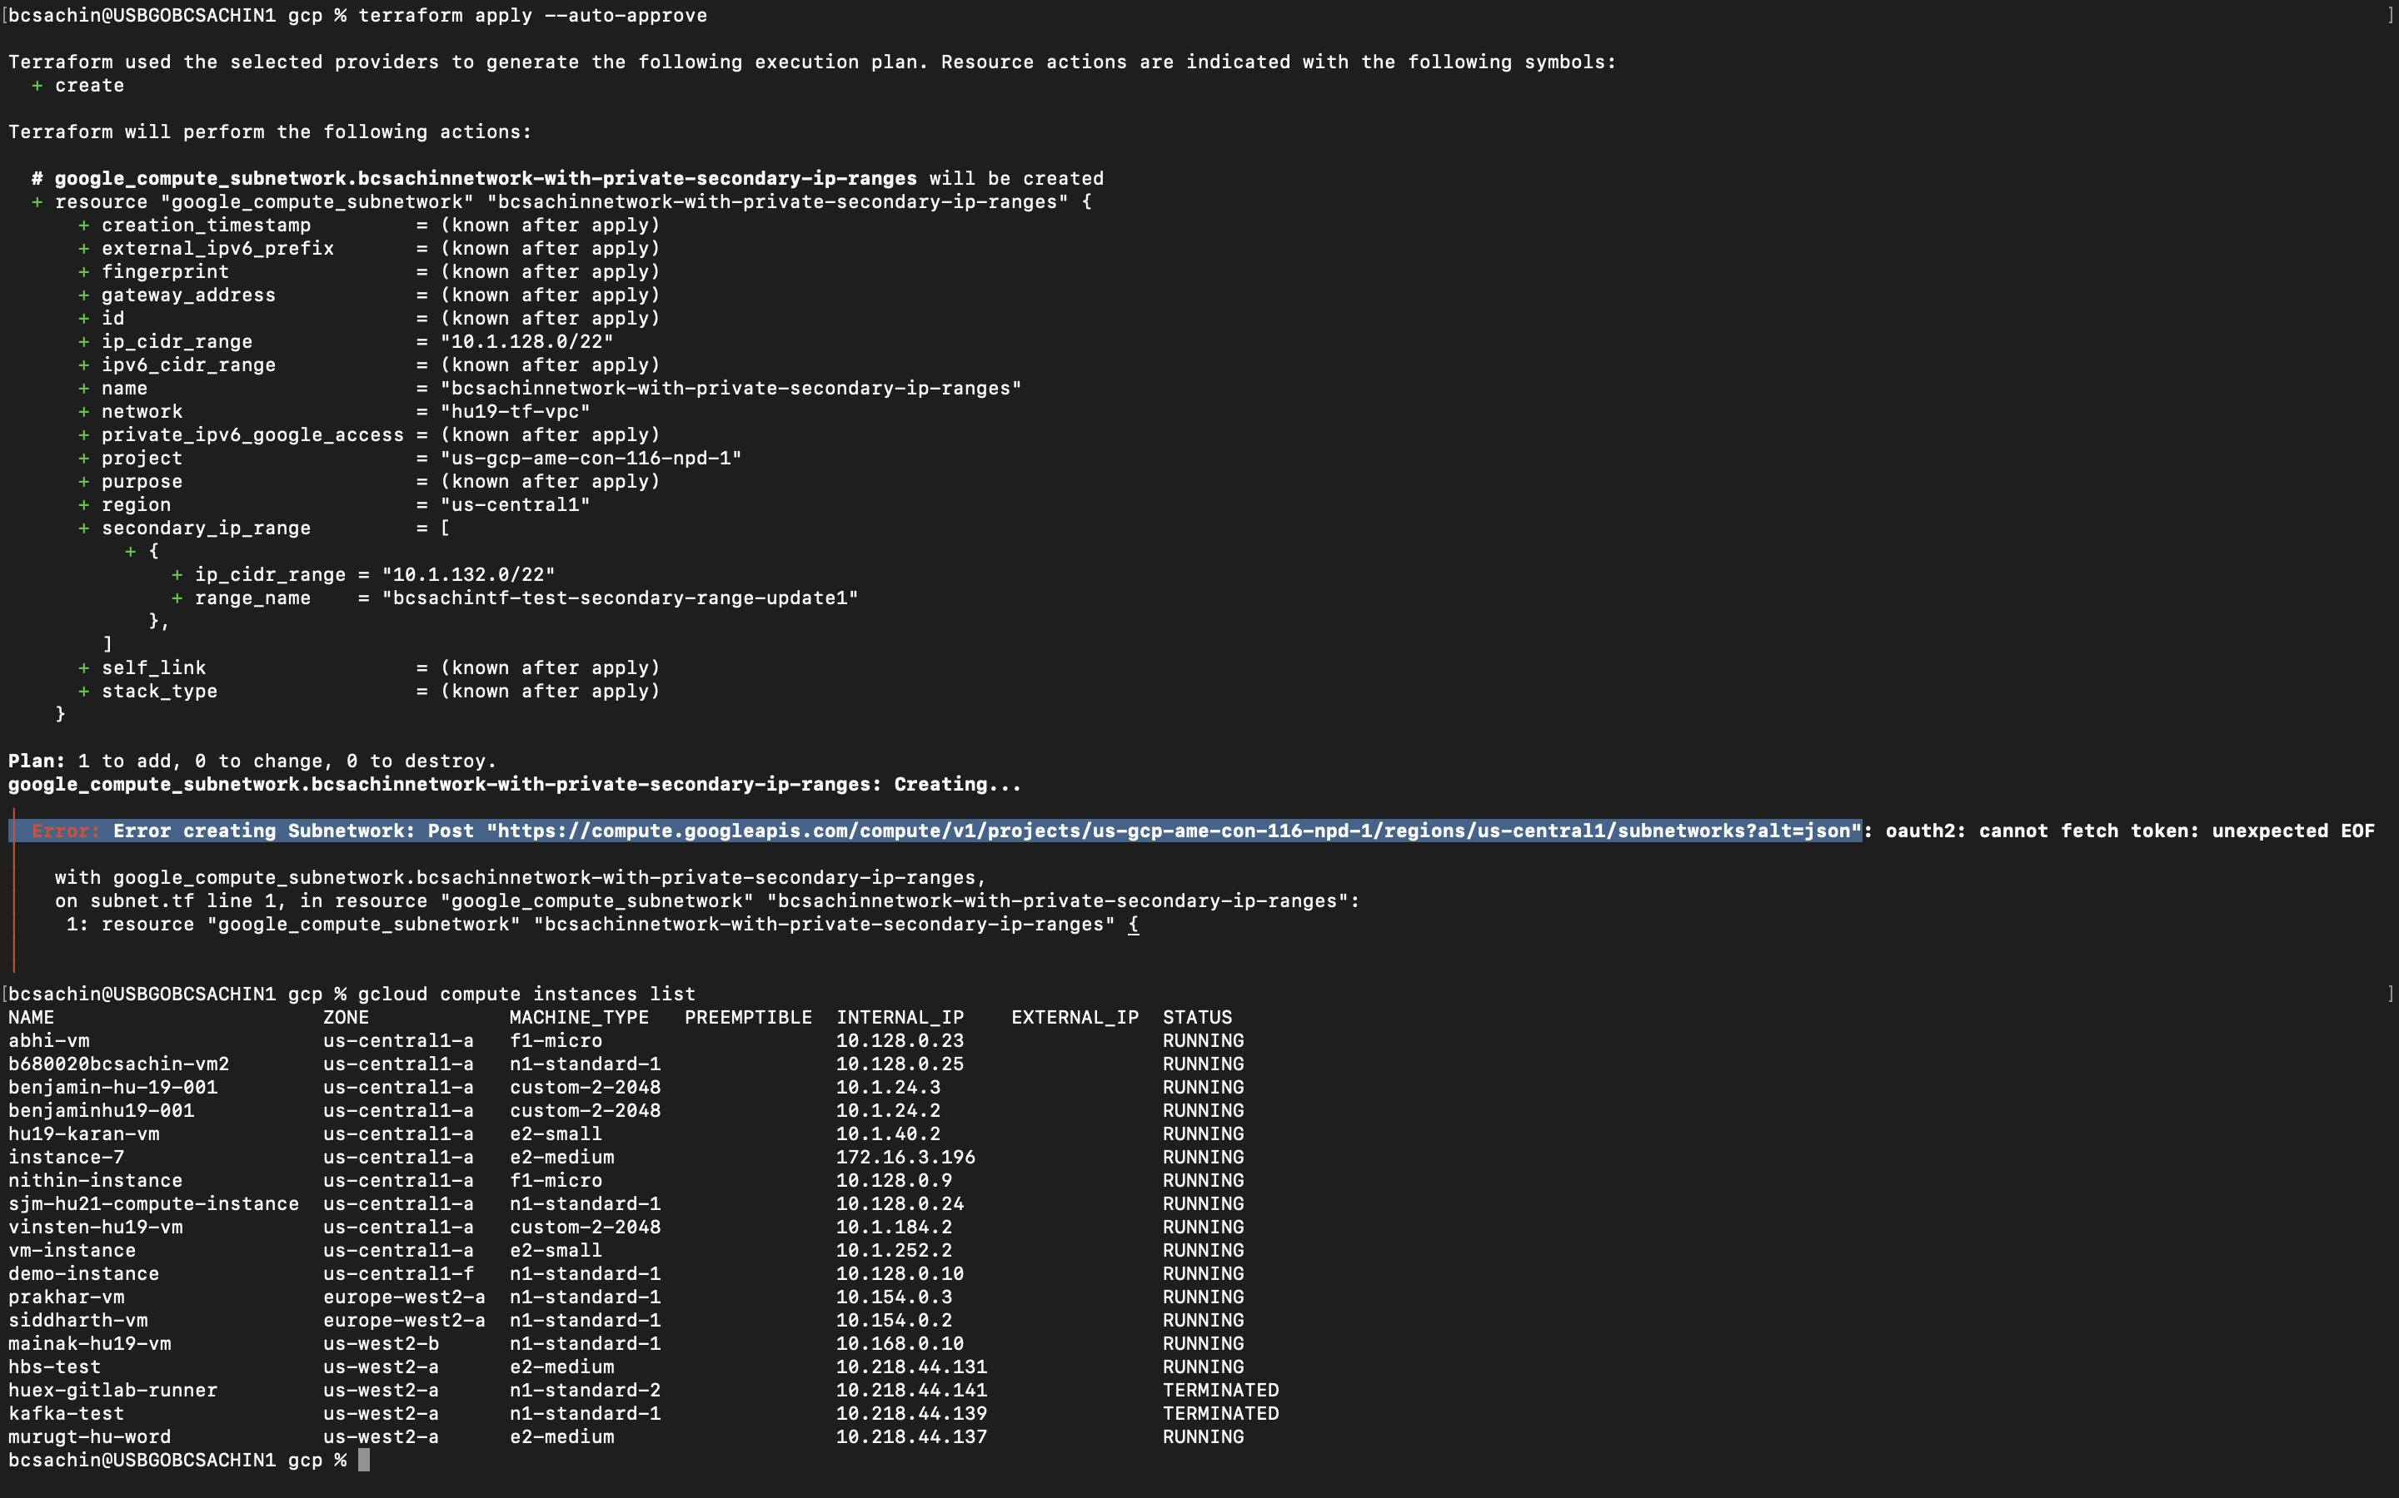

Oauth error

Gcp 2.

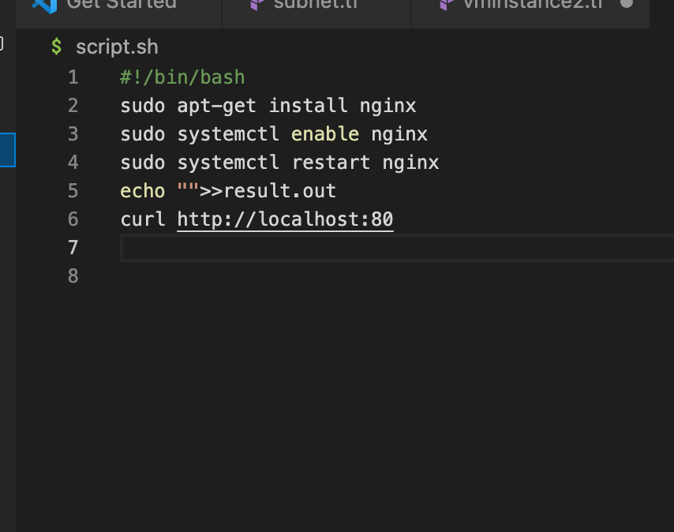

Script with deletion protection 